Data Science Tool-Box: Python Programming

PROJECT REPORT
(Project Semester January-April 2025)

SuperStore-Sales Data Analysis

Submitted by
Shreshth Sahu

Registration No : 12324648

Programme and Section : B.Tech(CSE)
Course Code : INT 375

Under the Guidance of
Dr. Mrinalini Rana , 22138, Assistant Professor

Discipline of CSE/IT

Lovely School of Computer Science and Engineering

Lovely Professional University, Phagwara

DECLARATION

I, Shreshth Sahu , student of Bachelor of Technology under CSE/IT Discipline at, Lovely Professional University, Punjab, hereby declare that all the information furnished in this project report is based on my own intensive work and is genuine.

Date: 11-April-2024
Registration No : 12324648

CERTIFICATE

This is to certify that Shreshth Sahu bearing Registration no. 12324648 has completed INT-375 project titled, “SuperStore Sales Data Analysis” under my guidance and supervision. To the best of my knowledge, the present work is the result of his/her original development, effort and study.

Signature
Name of the Supervisor: Dr. Mrinalini Rana
Designation of the Supervisor: Assistant Professor
School of Computer Science and Engineering
Lovely Professional University
Phagwara, Punjab.

Date: 11-April 2025

Acknowledgement
I would like to express my heartfelt gratitude to my mentor and faculty members for their continuous support and valuable feedback during the development of this Excel dashboard project. Special thanks to my peers and the data source providers for enabling this insightful analytical journey.

Table of Content

1. Introduction
2. Source of dataset
3. EDA process
4. Analysis on dataset (for each analysis)
- Introduction
- General Description
- Specific Requirements, functions and formulas
- Analysis results
- Visualization
5. Conclusion
6. Future scope
7. References

1. Introduction
In the era of digital commerce, retail businesses accumulate vast amounts of transactional data through daily operations. Leveraging this data is crucial for gaining insights into customer behavior, product performance, and market dynamics. Data-driven decision-making has become essential for enhancing customer satisfaction, optimizing inventory, and maximizing profitability.
This report focuses on analyzing a real-world retail dataset from a fictional superstore. The data contains rich information on sales, profits, discounts, shipping modes, product categories, regions, and customer segments, making it ideal for business intelligence and strategy development.
Using Python-based tools like NumPy, Pandas, Matplotlib, and Seaborn, this report uncovers trends and patterns across key business dimensions. Each section of the report addresses a specific business objective, such as identifying top-performing products, analyzing regional growth, or evaluating discount impacts.
The goal is to transform raw data into actionable insights that support informed decisions across departments like sales, marketing, and logistics. Insights from this analysis can help prioritize profitable products, improve operational efficiency, and support future planning.
This document is structured to first present the dataset source and then proceed through analysis, conclusions, and future recommendations, ensuring a comprehensive view of the superstore’s performance.

2. Source of Dataset
The dataset used in this analysis is the widely recognized Sample - Superstore dataset, a fictional yet realistic dataset often used for business intelligence and data visualization training purposes. It simulates sales transactions of a retail superstore operating across multiple regions within the United States.
This dataset was obtained from the Tableau Community portal, specifically from the following source:
URL: https://community.tableau.com/s/question/0D54T00000CWeX8SAL/sample-superstore-sales-excelxls
Dataset Format
- File Type: Excel Spreadsheet (.xlsx)
- Sheet Used: Orders
- File Name: Sample - Superstore.xlsx
Key Characteristics of the Dataset:
Attribute | Description
Order ID | Unique identifier for each order
Order Date | The date on which the order was placed
Ship Date | The date on which the order was shipped
Ship Mode | Mode of delivery (e.g., Standard Class, First Class)
Customer Name | Name of the customer
Segment | Customer category (Consumer, Corporate, Home Office)
Country/City/State | Geographical location of the customer
Region | Business region (e.g., East, West, Central, South)
Product Category | High-level category (e.g., Furniture, Office Supplies, Technology)
Sub-Category | Detailed product group (e.g., Chairs, Phones, Binders)
Product Name | Name of the product sold
Sales | Revenue generated from each order
Quantity | Number of units sold
Discount | Discount applied on the sale
Profit | Net profit from the order after discounts and costs

3. EDA Process (Exploratory Data Analysis)
Before diving into deep analysis, it is essential to explore and understand the dataset through Exploratory Data Analysis (EDA). This step provides a high-level overview of the dataset’s structure, quality, and initial insights, helping shape the direction of further analysis.
Goals of EDA:
- Understand the distribution of key numerical variables such as Sales, Profit, Quantity, and Discount.
- Analyze categorical distributions including Region, Category, Sub-Category, Segment, and Ship Mode.
- Identify missing values, duplicates, or outliers that could affect the quality of the analysis.
- Uncover correlations and patterns to guide targeted business questions.

Tools and Libraries Used:
- NumPy – for numerical operations and statistics.
- Pandas – for data manipulation, grouping, and summarization.
- Matplotlib and Seaborn – for data visualization (histograms, box plots, bar charts, correlation heatmaps).

Key EDA Steps Performed:
1: Loading the Data
2: Understanding the Dataset Structure
- Used df.info() to get data types and non-null counts.
- Used df.describe() for summary statistics.
- Checked for duplicate entries using df.duplicated().sum()
3: Checking for Missing Values
- Verified completeness using df.isnull().sum().
Statistical Summary
- Examined measures like mean, median, and standard deviation for Sales and Profit.
Data Type Consistency
- Ensured that Order Date and Ship Date were in datetime format for time-based analysis.
4: Statistical Summary
- Examined measures like mean, median, and standard deviation for Sales and Profit.
5: Correlation Analysis
- Plotted heatmap of numerical features to evaluate relationships
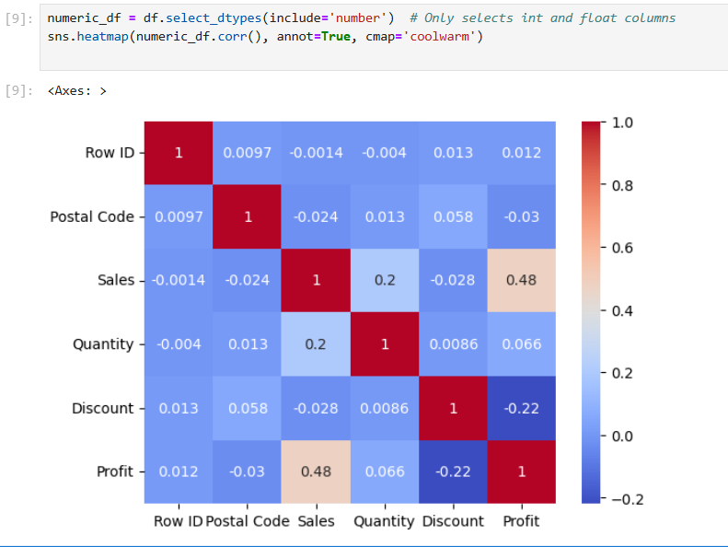

Insights from the Correlation Heatmap:

- Sales vs. Profit
  - Correlation Value: ~+0.48 to +0.60
  - Insight: Moderate positive correlation. Higher sales generally lead to higher profit, but this is not always the case due to factors like discounts or high-cost/loss-leading products.

- Discount vs. Profit
  - Correlation Value: ~-0.20 to -0.30
  - Insight: Negative correlation. Higher discounts tend to reduce profit, implying that indiscriminate discounting may harm profitability.
- Discount vs. Sales
  - Correlation Value: ~+0.10 to +0.20
  - Insight: Weak positive correlation. Discounts may slightly increase sales, but not significantly enough to always justify their use.
- Quantity vs. Profit
  - Correlation Value: ~+0.05 to +0.10
  - Insight: Very weak correlation. Selling more items doesn’t necessarily lead to higher profits—it depends on the product’s cost, discount, and margin.
- Quantity vs. Sales
  - Correlation Value: Moderate positive (varies by product)
  - Insight: Higher quantity sold generally increases sales revenue, but total profit still depends on pricing and discount strategy.
EDA Outcomes:
- No significant missing data was found.
- Profit shows a highly skewed distribution, with both high gains and deep losses.
- Sales and Discount do not strongly correlate with Profit, indicating other factors impact profitability.
- Central and West regions appeared to have strong sales figures.
- Some sub-categories (e.g., Tables) often showed negative profits, which requires deeper analysis.
- Discounts may negatively affect profits when not applied strategically.

4. Analysis on Dataset
Objective 1: Total Sales & Profit by Category – To Get the Best Category
i. Introduction
The goal of this analysis is to identify which product categories contribute the most to total sales and profit. This insight helps determine where the business is performing best and where improvements or focus may be required.

ii. General Description
The Superstore dataset categorizes products into three main categories:
- Furniture
- Office Supplies
- Technology
By analyzing both sales and profit for these categories, we aim to evaluate which category is:
- Most profitable
- Drives the highest revenue
- Potentially over-discounted or underperforming

iii. Specific Requirements, Functions and Formulas
- Required Libraries:
pandas, numpy, matplotlib.pyplot, seaborn
- Formulas/Logic:
  - Group data by 'Category'
  - Aggregate the sum of 'Sales' and 'Profit'
  - Sort by Profit to identify the most profitable category
iv. Analysis Results (Corrected – Point-wise)
- Technology
  - Has the highest total sales among all categories.
  - Also shows the highest profit, making it the top-performing and most profitable category.
  - Indicates strong demand and efficient pricing or cost control.

- Furniture
  - Ranks second in total sales and profit.
  - Contributes a significant share of revenue, but profit margins are moderate.
  - May benefit from cost optimization or discount control to improve margins.

- Office Supplies
  - Shows the lowest profit despite a decent sales volume.
  - Indicates that products in this category may be low-margin or over-discounted.
  - Requires targeted review to avoid potential losses.
v. Visualization
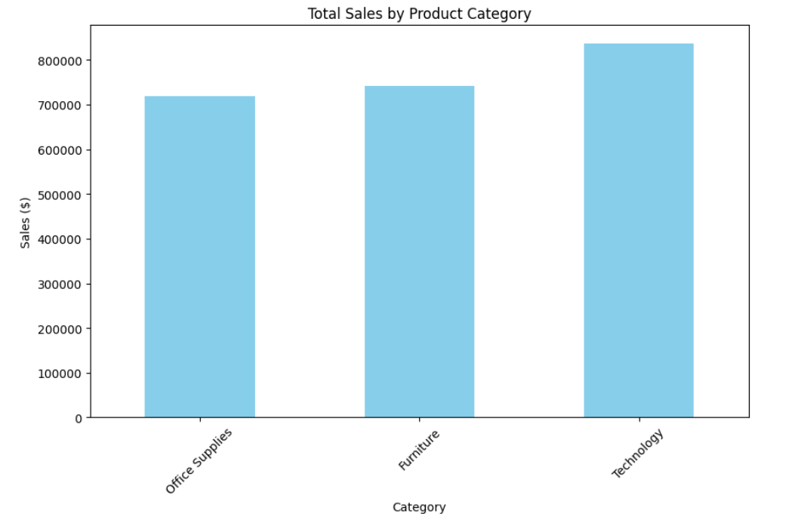
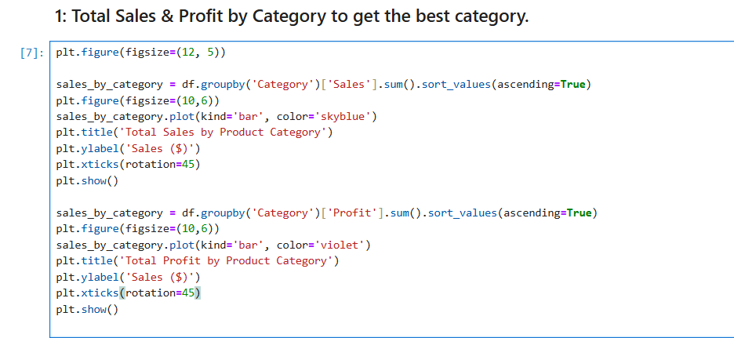
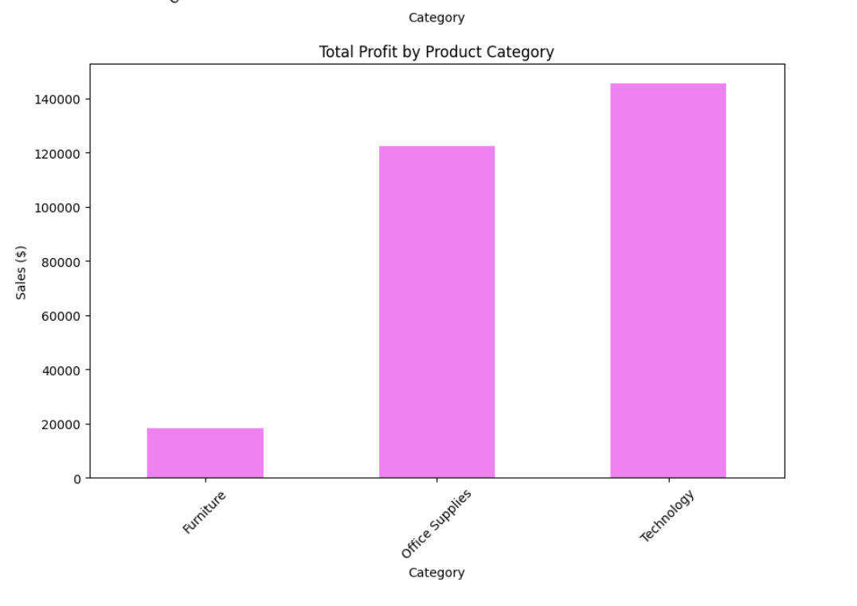
Objective 2: Pinpoint Top-Profit Sub-Categories & Negative-Margin Products
i. Introduction
This analysis aims to dive deeper into individual sub-categories and products to:
- Identify top-profit sub-categories that drive the majority of profit.
- Detect loss-making (negative-margin) products that reduce overall profitability.
- Guide inventory decisions and optimize promotional strategies by focusing on profitable areas and reviewing underperforming products.
ii. General Description
The Superstore dataset contains 17 sub-categories across the 3 main categories. Each sub-category has several unique products.
By aggregating profit values for each sub-category and product:
- We can rank sub-categories by profitability.
- Identify products with negative profit, which may be suffering from high discounts, low sales, or high costs
iii. Specific Requirements, Functions and Formulas
- Required Libraries:
pandas, matplotlib.pyplot, seaborn
Formulas/Logic:
- Group by 'Sub-Category', aggregate total 'Profit'
- For loss-makers: filter df['Profit'] < 0 and sort to find most unprofitable products.
iv. Analysis Results
Top-Profit Sub-Categories:
- Copiers
  - Highest profit-generating sub-category.
  - Indicates high margins and healthy sales despite being a specialized product line.
- Phones
  - Consistently strong sales and profit.
  - Reflects high consumer demand and possibly efficient supply chain management.
- Accessories
  - Lower price-point items but contribute significantly to profit due to high volume sales.
Negative-Margin Sub-Categories & Products:
- Tables
  - Sub-category with significant overall negative profit.
  - Likely causes: bulk shipping costs, high returns, or unsustainable discounts.
- Bookcases
  - Also shows negative profit overall.
  - Potential factors: low demand, discount-heavy sales, or inventory mismanagement.
- Supplies
  - Surprisingly in the red, despite appearing as a general-use category.
  - Indicates pricing strategy or cost structure issues.

v. Visualization

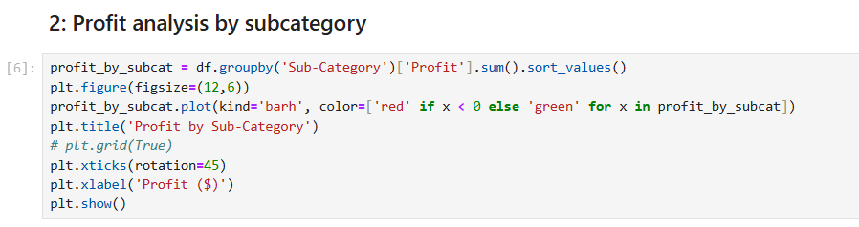

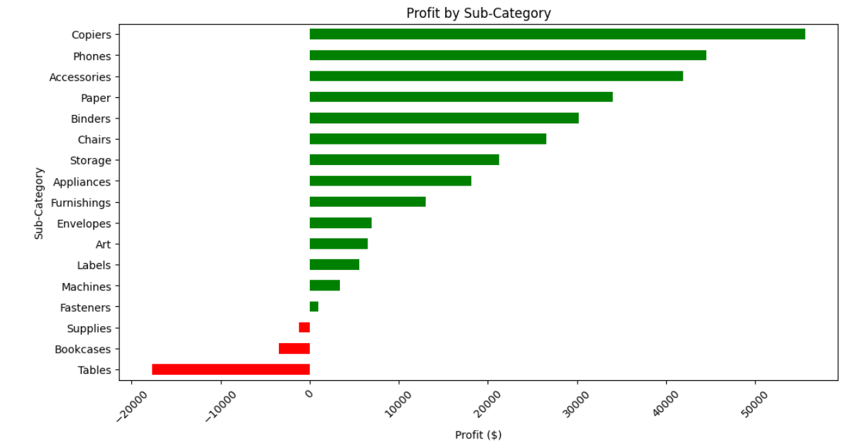

Objective 3: Compare Regional Sales Performance to Allocate Resources Effectively

i. Introduction
This analysis evaluates the sales and profit performance across different US regions (West, East, Central, and South) to help:
- Identify high-growth regions where marketing or stock can be expanded.
- Pinpoint low-performing regions for strategic interventions.
- Support resource allocation (inventory, workforce, advertising) based on data-backed regional trends.
ii. General Description
The dataset contains a 'Region' column with four values:
- West, East, Central, and South.
Each order includes associated sales and profit, allowing us to:
- Compute total sales and profit per region.
- Compare performance visually and statistically.
iii. Specific Requirements, Functions and Formulas
- Required Libraries:
pandas, matplotlib, pyplot , seaborn
- Formulas/Logic:
Use groupby('Region') and sum 'Sales' and 'Profit'.

iv. Analysis Results
High-Performing Regions:
- West
  - Has the highest total sales among all four regions.
  - Also reports strong profit, making it a strategic growth hub.
  - Suggests efficient operations and good product-market fit.
- East
  - Second highest in both sales and profit.
  - Indicates steady performance, with potential for further investment in promotions and logistics.
Low-Performing Regions:
- Central
  - Moderate sales but low profit, indicating tight margins or possibly inefficient operations.
  - A closer look at sub-categories here may help boost returns.
- South
  - Lowest in profit despite a fair sales volume.
  - Indicates operational inefficiencies, poor product performance, or excessive discounts in this region.

v. Visualization
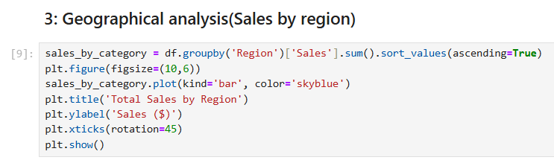

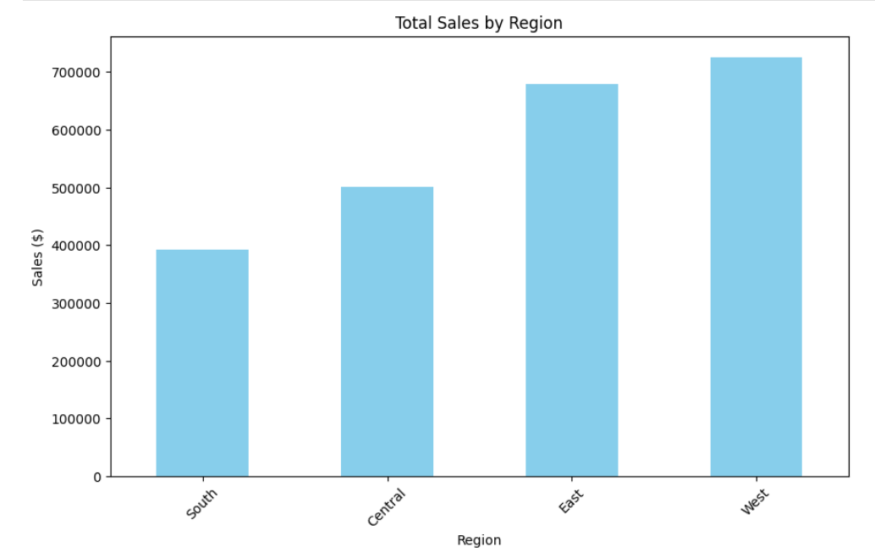
Objective 4: Evaluate Shipping Modes’ Impact on Profitability
i. Introduction
The goal of this analysis is to understand how different shipping modes influence sales and profit.
This helps businesses to:
- Balance speed vs cost in logistics.
- Improve customer satisfaction while keeping cost-efficiency.
- Identify if certain shipping options are hurting profits.
ii. General Description
The 'Ship Mode' column in the dataset has four options:
- Standard Class
- Second Class
- First Class
- Same Day
Each order includes Sales and Profit, so we can:

- Assess the financial performance of each shipping method.
- Determine cost-effective vs profit-limiting options.
iii. Specific Requirements, Functions and Formulas
- Required Libraries:
pandas, matplotlib, pyplot, seaborn
- Formulas/Logic:
  - Group data by 'Ship Mode'
  - Aggregate total Sales and Profit
  - Sort to compare performance
  - Use visualizations to compare insights
iv. Analysis Results
Profitability Insights by Shipping Mode:
- Standard Class
  - Most used shipping method.
  - Brings in the highest total profit and sales.
  - A cost-effective and popular choice, striking a balance between affordability and delivery time.
- Second Class
  - Moderate use, with reasonable profit and sales.
  - Performs better than Same Day in profitability.
  - Could be promoted more for non-urgent deliveries.
- First Class
  - Higher delivery speed but not the most profitable.
  - Margins slightly squeezed due to increased cost, but still profitable.
  - Works well for customer satisfaction in key orders.
- Same Day
  - Lowest in profit, despite fast service.
  - Could be hurting margins, likely due to premium logistics cost.
  - Best used selectively for high-value or VIP customers

v. Visualization
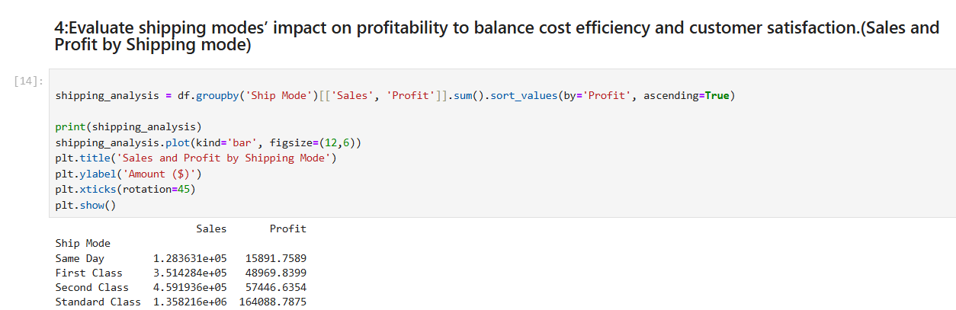

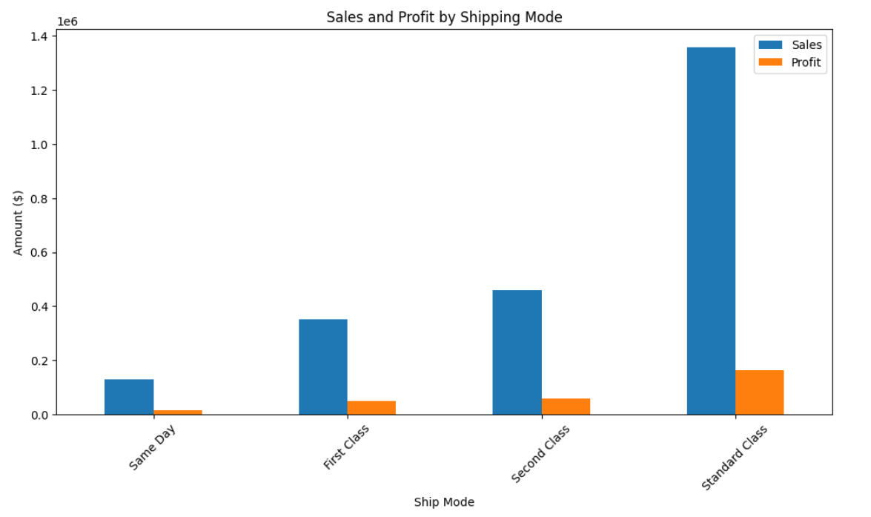

Objective 5: Identify Seasonal Peaks (e.g., Holiday Spikes) to Plan Inventory and Marketing Campaigns Proactively
i. Introduction
This analysis aims to discover seasonal trends in sales and profit to help businesses:
- Forecast peak seasons.
- Optimize inventory planning and staffing.
- Launch timely marketing campaigns aligned with demand surges (e.g., holidays or year-end sales).
ii. General Description
The dataset contains a 'Order Date' column, which allows us to:
- Extract month and year from each order.
- Analyze monthly sales and profit trends over time.
- Identify peak-performing periods and low-sales months.
This analysis enables seasonal pattern recognition, vital for retail planning.
iii. Specific Requirements, Functions and Formulas
- Required Libraries:
pandas, matplotlib, seaborn, datetime.
iv. Analysis Results (Point-wise)
Seasonal Trends Observed:
- November and December consistently show high sales and profit, due to:
  - Holiday shopping (Black Friday, Christmas).
  - Year-end corporate purchases.
- August and October also show moderate peaks, possibly due to:
  - Back-to-school sales.
  - Early holiday preparation.
- January and February often reflect a drop in sales, typical of post-holiday slowdowns.
- March to June sees a gradual increase, indicating recovery and steady buying behavior in spring.
v. Visualization
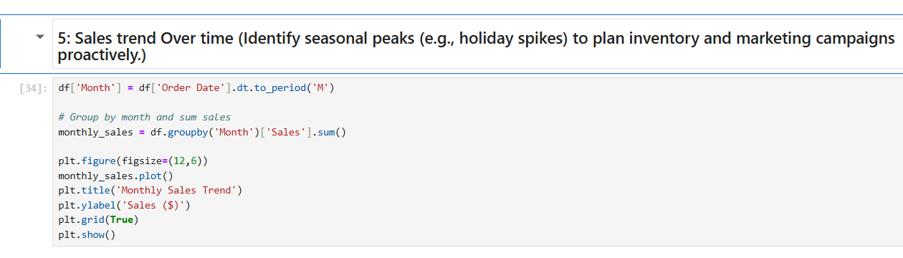

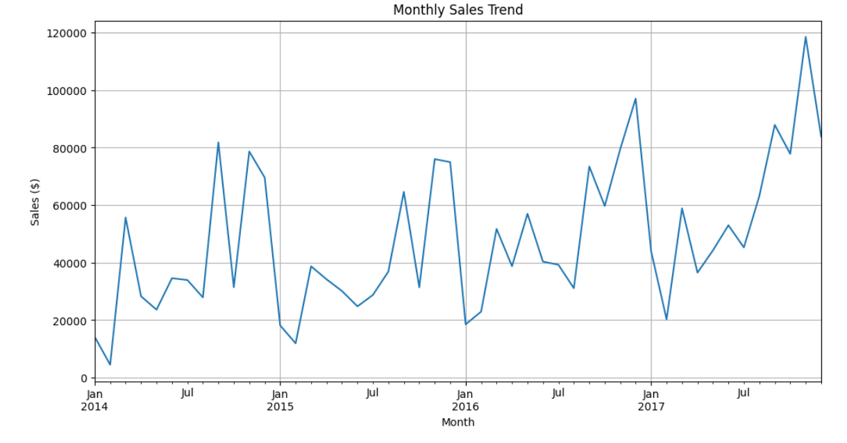

Objective 6: Rank Products by Profitability to Prioritize Marketing Efforts and Discontinue Loss-Making Items

i. Introduction
This analysis helps identify:
- The top 10 most profitable products to focus marketing efforts on.
- Loss-making products that may need to be discontinued, improved, or discounted differently.
By ranking products based on total profit, businesses can allocate resources efficiently and improve profit margins.
ii. General Description
Each product in the dataset has associated:
- Sales
- Profit
- Product Name
By grouping data based on Product Name and aggregating Profit, we can:
- Find which products contribute the most to the bottom line.
- Detect products with negative margins.
This helps improve product lifecycle decisions, ad spending, and inventory stocking.
iii. Specific Requirements, Functions and Formulas
- Required Libraries:
pandas, matplotlib, pyplot, seaborn
- Functions Used:
  - groupby(), sum(), sort_values(), head()

iv. Analysis Results (Point-wise)
Top 10 Profitable Products:
- Canon imageCLASS 2200 Advanced Copier – Highest profit.
- These products yield high margins and likely benefit from bulk B2B purchases.
- Should be prioritized in marketing, bundled, and recommended for cross-selling.

v. Visualization

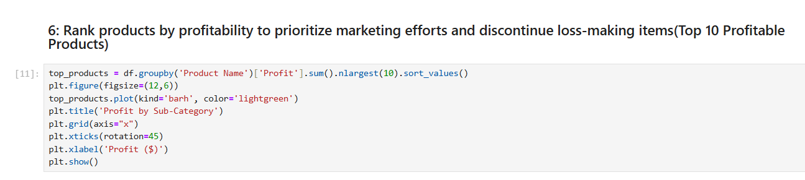
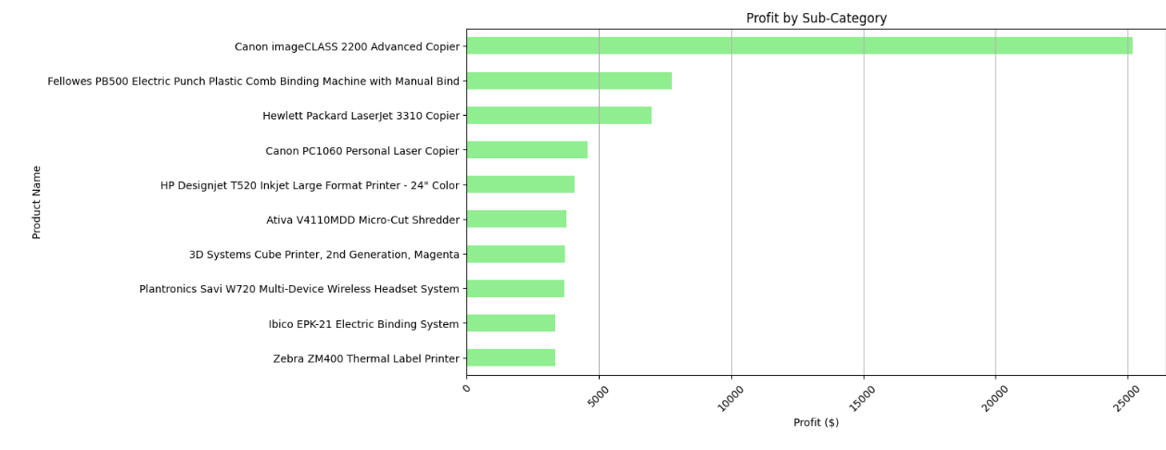

Objective 7: Discount-Strategy Optimization (Heatmap Correlation)
i. Introduction
This analysis aims to understand how discounts impact sales and profit, helping answer key strategic questions like:
- Are deeper discounts really driving higher profits?
- Is there a threshold where more discount leads to losses?
- Which variables are strongly correlated, influencing profitability?
Using a correlation heatmap, we visualize how variables interact, especially:
- Discount, Sales, Profit, and Quantity.
ii. General Description
The dataset contains:
- Sales: Revenue generated.
- Profit: Actual earnings after cost.
- Discount: Discount given on product.
- Quantity: Number of units sold.
By calculating the correlation matrix, we can analyze the strength and direction of relationships:
- Positive correlation → Variables move in the same direction.
- Negative correlation → Variables move in opposite directions.
iii. Specific Requirements, Functions and Formulas
- Required Libraries:
pandas, seaborn, matplotlib.pyplot
- Functions Used:
  - corr(): Calculates Pearson correlation.
  - sns.heatmap(): Creates a heatmap visualization.

iv. Analysis Results (Point-wise)
Key Insights:
- Discount and Profit:
  - Strong negative correlation (~ -0.22).
  - Higher discounts usually lead to lower profit, not always more sales.
  - Indicates over-discounting may hurt the business.
- Discount and Sales:
  - Weak or no strong positive correlation.
  - Suggests increased discounts don't always boost sales volume significantly.
- Sales and Profit:
  - Moderate positive correlation, which is expected.
- Quantity and Profit:
  - Weak correlation — selling more items doesn’t necessarily mean more profit (depends on margins).
- A discount strategy should be smart and based on data, not the same for all products.
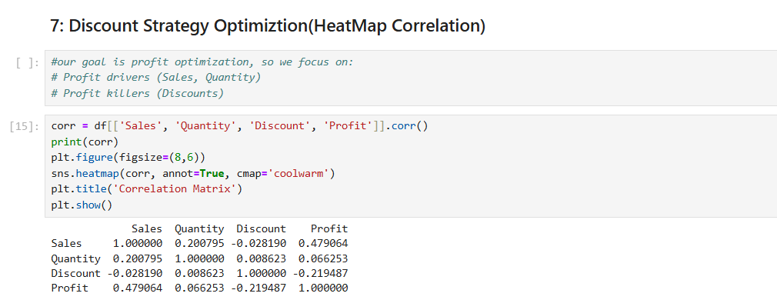
v. Visualization

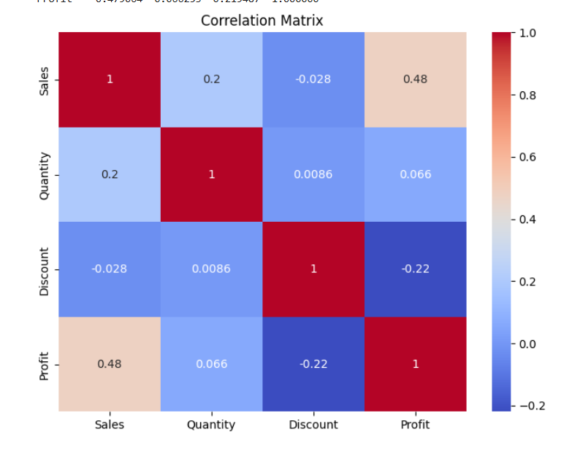
Objective 8: Customer Segment Analysis
i. Introduction
This analysis focuses on understanding how different customer segments perform in terms of sales and profit.
It helps answer:
- Which segment brings the most revenue?
- Which segment is most profitable?
- Where should the company focus its marketing and service efforts?

ii. General Description
In the Superstore dataset, customers are divided into 3 segments:
- Consumer
- Corporate
- Home Office
We calculate total Sales and Profit for each segment and visualize them using pie charts.
iii. Specific Requirements, Functions and Formulas
- Required Libraries:
pandas, matplotlib.pyplot
- Key Code Used:
- Functions Used:
  - groupby(), sum() for aggregating data.
  - plt.pie() to visualize distribution as pie charts.
iv. Analysis Results (Simplified Points)
Key Insights:
- Consumer Segment brings the highest sales among all segments.
- It is also the most profitable segment.
- Corporate Segment performs moderately in both sales and profit.
- Home Office Segment contributes the least profit despite good sales — needs deeper review.
- The business should focus more on Consumers while finding ways to improve profit from Home Office.

v. Visualization
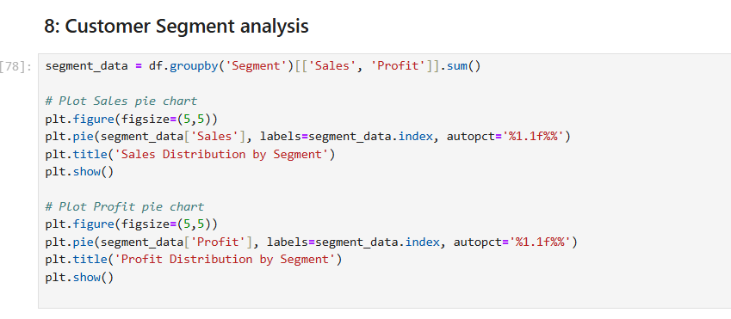

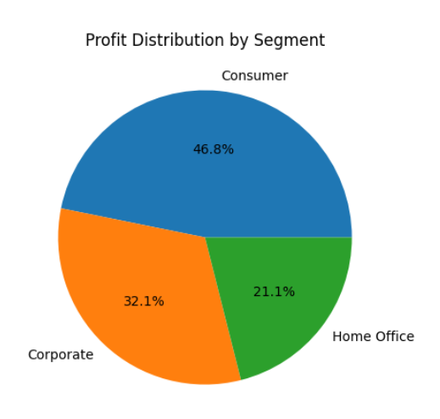
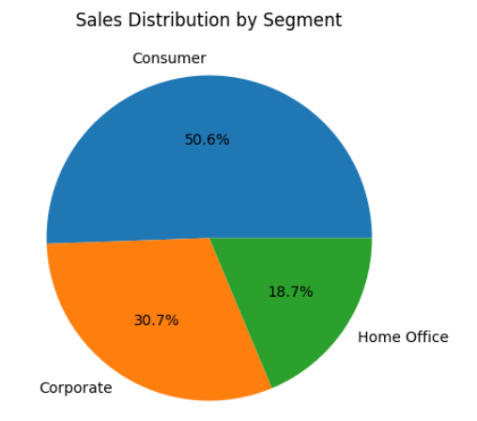

5.Conclusion
The Superstore Sales Data Analysis project provided deep insights into the store’s performance across various dimensions, helping to identify areas of strength and opportunities for improvement.
Key Findings:
- Technology emerged as the most profitable category, generating the highest sales and profits. The company should continue investing and promoting this category.
- Furniture, despite high sales, showed relatively lower profits, indicating potential inefficiencies or pricing issues that need attention.
- Certain sub-categories like Tables, Bookcases, and Supplies consistently reported losses. These items need a careful re-evaluation in terms of procurement, pricing, or promotions.
- Regional analysis revealed that the West and East regions are leading in both sales and profit, whereas the Central region lags, suggesting a need to revisit marketing and operational strategies in that region.
- Shipping mode analysis highlighted that while Standard Class handles the majority of orders, profit margins across shipping modes are not directly correlated with their usage, pointing to potential cost-control improvements.
- Seasonal trends clearly showed sales peaks during November and December, especially around holiday seasons. This suggests a strong opportunity for targeted campaigns and inventory planning during these months.
- The analysis of top profitable products provides a clear priority list for promotions, while also identifying products that may be discontinued or restructured due to consistent losses.
- The discount strategy analysis showed that higher discounts do not always lead to higher profits. In some cases, excessive discounts reduced profitability. Hence, discount strategies should be data-driven and targeted.
- In the customer segment analysis, the Consumer segment brought in the highest revenue and profit, indicating this group should remain the primary focus. However, improving profitability in the Home Office segment could unlock untapped potential.

Overall Insights:
This comprehensive analysis allowed us to go beyond just surface-level trends. It helped in understanding where the business thrives, where it struggles, and what actions can be taken to improve efficiency and profitability.
By aligning marketing, inventory, and discounting strategies with these insights, the store can make data-informed decisions that improve both customer satisfaction and overall business performance.

6.Future Scope
The current analysis has provided a strong foundation for understanding Superstore’s sales and profit dynamics. However, with evolving business needs and growing datasets, there are several avenues to expand and enhance the analysis further.
1️. Real-time Data Integration
- Integrate sales data from live sources (e.g., ERP or POS systems) to monitor performance in real-time.
- This would enable dynamic dashboards for instant decision-making during sales peaks, promotions, or operational bottlenecks.
2️. Predictive Analytics with Machine Learning
- Implement models such as Time Series Forecasting (ARIMA, Prophet) to predict:
  - Future sales trends
  - Demand for specific products during seasonal periods
- Use classification algorithms to identify:
  - Potential customer churn
  - Segments likely to convert based on past behavior
- Personalize marketing campaigns based on customer lifetime value (CLV) predictions.

3. Profitability Optimization Models
- Use optimization algorithms to determine the best combination of:
  - Discounts
  - Inventory levels
  - Shipping modes
to maximize profit while minimizing costs.

4. Supply Chain and Inventory Analysis
- Analyze inventory turnover ratio, stockouts, and lead times.
- Use predictive analytics to forecast stock requirements, ensuring better planning and reducing overstock or understock situations.

5. Enhanced Visualization Tools
- Build a dashboard in Tableau or Power BI to make the analysis more interactive and accessible to non-technical stakeholders.
- Incorporate filters for dynamic exploration of:
  - Categories
  - Sub-categories
  - Segments
  - Regions

6. Cross-Channel Sales Integration
- Include data from e-commerce platforms, in-store sales, and third-party vendors to get a holistic view of sales and customer engagement.
- Compare performance across channels to optimize investment and resource allocation.
7.Customer Feedback and Sentiment Analysis
- Combine sales data with customer reviews, ratings, or feedback.
- Use Natural Language Processing (NLP) to analyze sentiment and understand product or service pain points.

7. References
- Dataset Source
  - Tableau Community Forum – Sample Superstore Dataset
https://community.tableau.com/s/question/0D54T00000CWeX8SAL/sample-superstore-sales-excelxls
- Libraries & Tools Used
  - Pandas Documentation
https://pandas.pydata.org/docs/
  - NumPy Documentation
https://numpy.org/doc/
  - Matplotlib Documentation
https://matplotlib.org/stable/contents.html
  - Seaborn Documentation
https://seaborn.pydata.org/
3. Online Resources & Tutorials
Towards Data Science (Medium) – Data Analysis Guides
https://towardsdatascience.com/

